Global Research & Survey App (GRS) — Technical Blueprint
First use: Door-to-Door Skills Campaign (forms DD/S/001/2026 and DD/S/002/2026) · Android first, iOS later · Flutter + NestJS + Supabase · Offline-first
Prepared for Imantha · Version 1.3 · 25 October 2026

1. Purpose and Goals
The Global Research & Survey App (GRS) lets field teams collect survey data on an Android phone and keeps every record in one central database, even when the agent has no internet. Its first use is the Door-to-Door Skills Campaign, where teams visit households and record each person's education, vocational background, interests and welfare benefits. Today that work is done on paper forms, and this app replaces them.
Goals
- Agents fill in household and client details on an Android phone.
- Everything works offline; data is saved on the phone and synced later.
- All data ends up in one Supabase database that officers at every level can view according to their role.
- Simple to build, simple to use, easy to extend to iOS.
Non-goals for version 1 (to keep it simple): photo or document uploads, in-app chat, push notifications, analytics beyond basic counts, complex approval workflows.

2. Decisions Already Made
Topic | Decision
App name | Global Research & Survey App (GRS)
Mobile framework | Flutter (one codebase)
Backend API | NestJS (Node.js, TypeScript)
Database | Supabase (managed PostgreSQL)
First platform | Android; iOS later from the same code
Mobile users | Levels 0 to 5 (Level 00 works on the web), on their own phones (Android 10 or newer)
Web users | All levels, Level 00 first
Expected agents | Long-term goal of 50,000 to 1,000,000; the first launch is smaller
Offline sync | Automatic when internet returns and a manual "Sync now" button
Languages | Sinhala, English and Tamil in the app, dashboard and reports
Accounts | Created by admins; generated ID (GRS + 10 digits) and random password; users can switch to email login and change the password
House list loading | Bulk import from Excel, or typed one by one
Reports | The platform's own reports (not a government format)
Distribution | Direct APK for now
Data access | Super admin and admin Levels 0 to 4, each seeing the records related to them
Verdict on your stack: Flutter + NestJS + Supabase is still a good fit, but at the long-term goal of 50,000 to 1,000,000 agents the design around it must change: a larger database, careful sync traffic, pre-calculated dashboard numbers and load testing (section 6.1). The stack itself does not have to change.

3. Users and Roles
The hierarchy comes from the DD/S/002/2026 admin panel design. Each level sees only the data below it.
Level | Role | Platform | Main job
00 | Super admin | Web | Full system control; sets team member limits; sees all data
0 | Admin (role not decided yet) | Web and mobile | To be decided with the client
1 | Admin CG | Web and mobile | Creates Level 2 admins and own team members; enters data; sees the records of their area
2 | Admin DC | Web and mobile | Creates Level 3 admins and own team members; enters data; sees the records of their area
3 | Admin SDA | Web and mobile | Creates Level 4 team leaders and own team members; enters data; sees the records of their area
4 | CDC Secretary (team leader) | Mobile (and web) | Creates Level 5 members for their team; chooses the team's houses; enters data; sees the team's records
5 | CDC Team member | Mobile | Visits houses and enters client details; sees their own records
Build order: Level 00, Level 4 and Level 5 are built first. Levels 1 to 3 use the same app and dashboard, plus account creation, and follow next. Level 0 waits until its role is decided.
Account creation: every account is created by an admin on the level above, and the system generates the ID and password (section 3.1). Section 3.2 shows who creates whom.
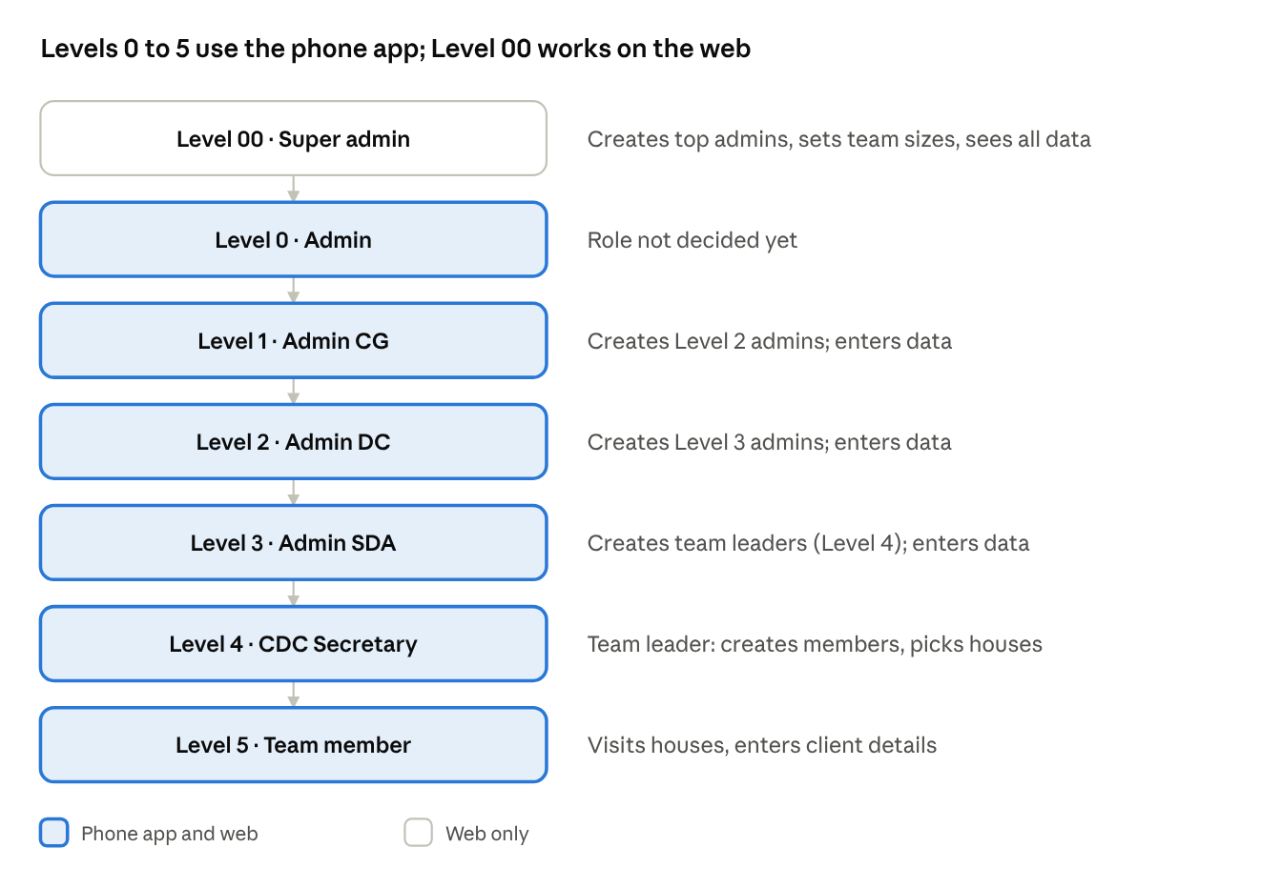
account hierarchy · 7 levels
Every level from 0 to 5 can use the Android app and enter data; Level 00 works on the web.

3.1 Accounts: generated ID and password
Every account is created by an admin on the level above. The system generates the login details, so nobody chooses or shares a password by hand.
- The admin creates the account (name, role, area, team), one at a time or in bulk. The system generates an ID made of GRS and 10 random digits (for example GRS1234567890) and a random password.
- The admin sees the ID and password once and hands them to the person: a printed sheet, or a downloaded list for bulk creation.
- The person signs in with the ID and password. The first sign-in needs internet and forces a new password.
- The person can add their own email, verified by a code. From then on they can sign in with either the ID or the email, plus the password.
- Forgotten password: if an email was added, it is reset by an emailed code; otherwise the admin who created the account issues a new random password.
Rules that keep this safe
- IDs are random, not sequential, and checked for duplicates when the account is created.
- A 10-digit ID is easy to guess in principle, so login errors never say whether an ID exists, and logins are rate-limited per ID, email and device.
- Passwords are random, stored only as hashes (Argon2), and cannot be shown again after the admin sees them once; a reset makes a new one.
- A password that is never used expires after a set time.
- A deactivated account is refused at once, even on a phone that is already signed in.
- The team's member limit is checked when an admin creates a member; a full team cannot take more.
- One email can belong to one account only.

3.2 Who creates whom
Admins create the accounts for the level directly below them, and Levels 1 to 4 also create their own team members. This is my reading of the client's note and should be confirmed.
Level | Can create accounts for
00 | Level 0 and Level 1 admins, and any other level
0 | To be decided
1 | Level 2 admins, and their own team members
2 | Level 3 admins, and their own team members
3 | Level 4 team leaders, and their own team members
4 | Level 5 team members of their team
5 | No one
A team's member limit, set by Level 00 (or Level 0 later), stops an admin from creating more members than the team allows.

3.3 What each level can see and enter
Level | App | Enters data | Sees records of
00 | Web | Not stated | All records
0 | Web and mobile | Yes | Own area and below, plus own entries (role to be decided)
1 to 3 | Web and mobile | Yes | Own area and below, plus own entries
4 | Mobile (and web) | Yes | Own team and below, plus own entries
5 | Mobile | Yes | Own entries
Every level has a records view that shows the records related to it.

4. What Data Is Collected

4.1 Pre-visit data (DD/S/002/2026), entered by Level 4
- District, Divisional Secretariat, GN division number and name
- CDC Secretary name, contact number, email
- House list taken from the election name list: serial number (auto), house number, house leader name, address, village name
- Beneficiary flags per house: EPF, ETF, Aswesuma, Samurdhi, special needs
- Number of target beneficiaries, age group (for example 18 to 25), language used (Sinhala, Tamil, English)
- Team grouping: which house numbers belong to which team (Team 1 gets houses 25, 26, 28 and so on)

4.2 Client data (DD/S/001/2026), entered by Level 5 at the door
House-level fields from section 4.1 appear automatically; the agent fills in:
- Name
- Age
- Gender (female or male)
- Address
- Phone number
- WhatsApp number
- Highest education qualification
- Highest vocational qualification
- Interested vocational stream
- Interested job
- Beneficiary type (EPF, ETF, Aswesuma, Samurdhi)
- Special needs: yes or no
- Future hopes (one or more): higher education, vocational education, entrepreneur, local job, foreign job
- Information provided by: self, mother, father, sister, other
One house can have several clients, so the app loops "Enter next beneficiary" until the agent taps End.

4.3 Loading the house list: Excel import or typing
Level 4 can load the houses from the election name list in two ways.
- Excel import (for large lists): download the template, fill it in (house number, house leader, address, village, beneficiary flags, target counts), and upload it on the web dashboard. The API checks every row and shows a preview with errors per row, such as a missing house number or a duplicate in the same GN division. Nothing is saved until the secretary confirms.
- Typed entry: one house at a time in the app or the dashboard, with the serial number added automatically.
- Each import is recorded as a batch (who, when, how many rows passed and failed).
- Version 1 keeps Excel import on the web dashboard, which Level 4 can also use, so the phone app stays simple. Each file must stay under 4.5 MB because of the hosting limit, which should be ample for a GN division's house list.
Excel template columns (one row per house), taken from the Level 4 section of the format file:
Column | Required | Notes
House No | Yes | Unique inside the GN division
Name of house leader | Yes | As on the election name list
Address | No
Name of village | No
Aswesuma | No | Yes or no
ETF | No | Yes or no
EPF | No | Yes or no
Samurdhi | No | Yes or no
Special needs | No | Yes or no
Target beneficiaries: female | No | Whole number
Target beneficiaries: male | No | Whole number
Age group | No | Such as 18-25
Language: Sinhala | No | Yes or no
Language: Tamil | No | Yes or no
Language: English | No | Yes or no
The serial number is added automatically. District, divisional secretariat, GN division number and name, and the CDC Secretary's name, contact and email are set once for the GN division, so they are not repeated in every row.

5. Technology Stack
Layer | Technology | Why
Mobile app | Flutter (Dart) | One codebase for Android now, iOS later, plus web
State management | Riverpod | Simple, popular, testable
Local database (offline) | Drift (SQLite) with SQLCipher | Reliable structured storage on the phone, encrypted
Navigation | go_router | Standard Flutter routing
Connectivity detection | connectivity_plus + internet_connection_checker_plus | Know when internet is really back
Background sync | workmanager | Runs sync on Android even if the app is closed
Backend API | NestJS (Node.js, TypeScript) | One API for the app and the dashboard: login, sync, import, reports, role checks
Data access in the API | Prisma (or TypeORM) | Typed queries and database migrations
Database | Supabase (managed PostgreSQL) | Backups, dashboard, familiar SQL
Authentication | JWT access and refresh tokens issued by NestJS; passwords hashed with Argon2 | Supports login by ID or email and generated passwords
Validation and API docs | class-validator and Swagger (OpenAPI) | Same rules for every client, clear contract
Excel import and export | ExcelJS | Reads the house-list template, writes Excel reports
PDF reports | A PDF library, chosen after a Sinhala and Tamil font test | Sinhala and Tamil text must render correctly
Email | A transactional email service | Verification and password-reset codes
Web dashboard | Flutter Web (same codebase and models) | Avoids learning a second framework
Localization | Flutter intl (ARB files), Noto Sans Sinhala and Noto Sans Tamil fonts | Sinhala, English and Tamil on every phone
API hosting | Vercel (likely), as a serverless function | Limits to design around are in section 6
Error tracking | Sentry (free tier) | See crashes from field devices
Source control and CI | GitHub + GitHub Actions | Automated tests and signed Android builds
Why not a bigger sync framework? Tools like PowerSync give automatic two-way sync, but add cost and complexity. Your data is mostly one-way (agent to server) and each house is handled by one team, so a small custom "outbox" sync is enough. You can upgrade later if needs grow.

5.1 Languages: Sinhala, English and Tamil
- A language picker on the login screen and in settings; the choice is saved on the profile and applies to the app, the dashboard and exports.
- Every screen, button, validation message and error is translated, with one translation file per language.
- Dropdown values (education, vocational stream, jobs, future hopes) are stored as stable codes with three labels, so any report can show any language.
- Noto Sans Sinhala and Noto Sans Tamil are bundled in the app so text looks the same on every phone, including older ones.
- Names and addresses can be typed in any of the three scripts; text is stored as UTF-8 end to end.
- Sinhala and Tamil wording is reviewed by native speakers before the pilot, using the wording of the official forms.

6. System Architecture
The system has four parts: the Android app used in the field, the NestJS API, the Supabase database, and the web dashboard used by higher officers. Both apps talk only to the API.
- Android app (Levels 0 to 5): UI → Riverpod → Repository → Drift local DB → Sync Service → NestJS API.
- NestJS API: modules for login and accounts, sync, Excel import, reports, and user and area management, with role guards that limit every request to the user's area.
- Supabase (PostgreSQL): stores all data; Row Level Security stays on as a second safety net.
- Web dashboard (all levels, Level 00 first): Flutter Web calling the same API.
Why an API in the middle: the account rules, Excel import, sync checks and reports live in one place, and the apps never hold database keys.
Hosting recommendation: Supabase, region Singapore (closest to Sri Lanka), on a paid plan with a compute size chosen after load tests (section 6.1). The free tier pauses inactive projects and has no daily backups, which is not acceptable for real citizen data.
NestJS on Vercel (your likely choice): Vercel runs a NestJS app as one serverless function, which suits this project if the limits in Vercel's function limits are designed around from the start:
- Region: functions run in one region, iad1 (US East), by default. Change it to the region nearest the Singapore database, or every request pays a long trip.
- Request and response size: 4.5 MB each. Sync batches are small text and fit; Excel imports and report downloads must stay under it, or go through Supabase Storage with a link.
- Run time: 300 seconds by default (up to 800 on the Pro plan), enough for a large import or report.
- Bundle size: 250 MB uncompressed, so PDF reports should use a light library, not a bundled browser.
- Database connections: connect through Supabase's connection pooler, because each function opens short-lived connections and Vercel limits open file descriptors to 1,024, shared across running functions.
- No background loop: nothing runs between requests, so scheduled jobs use Vercel Cron instead of a scheduler inside NestJS.
- Plan: check that the free Hobby plan's terms allow a government campaign; the Pro plan raises the limits above.
- Cost at scale: usage-based charges are likely to grow with the number of requests and the data moved, which is another reason to batch sync requests (section 6.1).
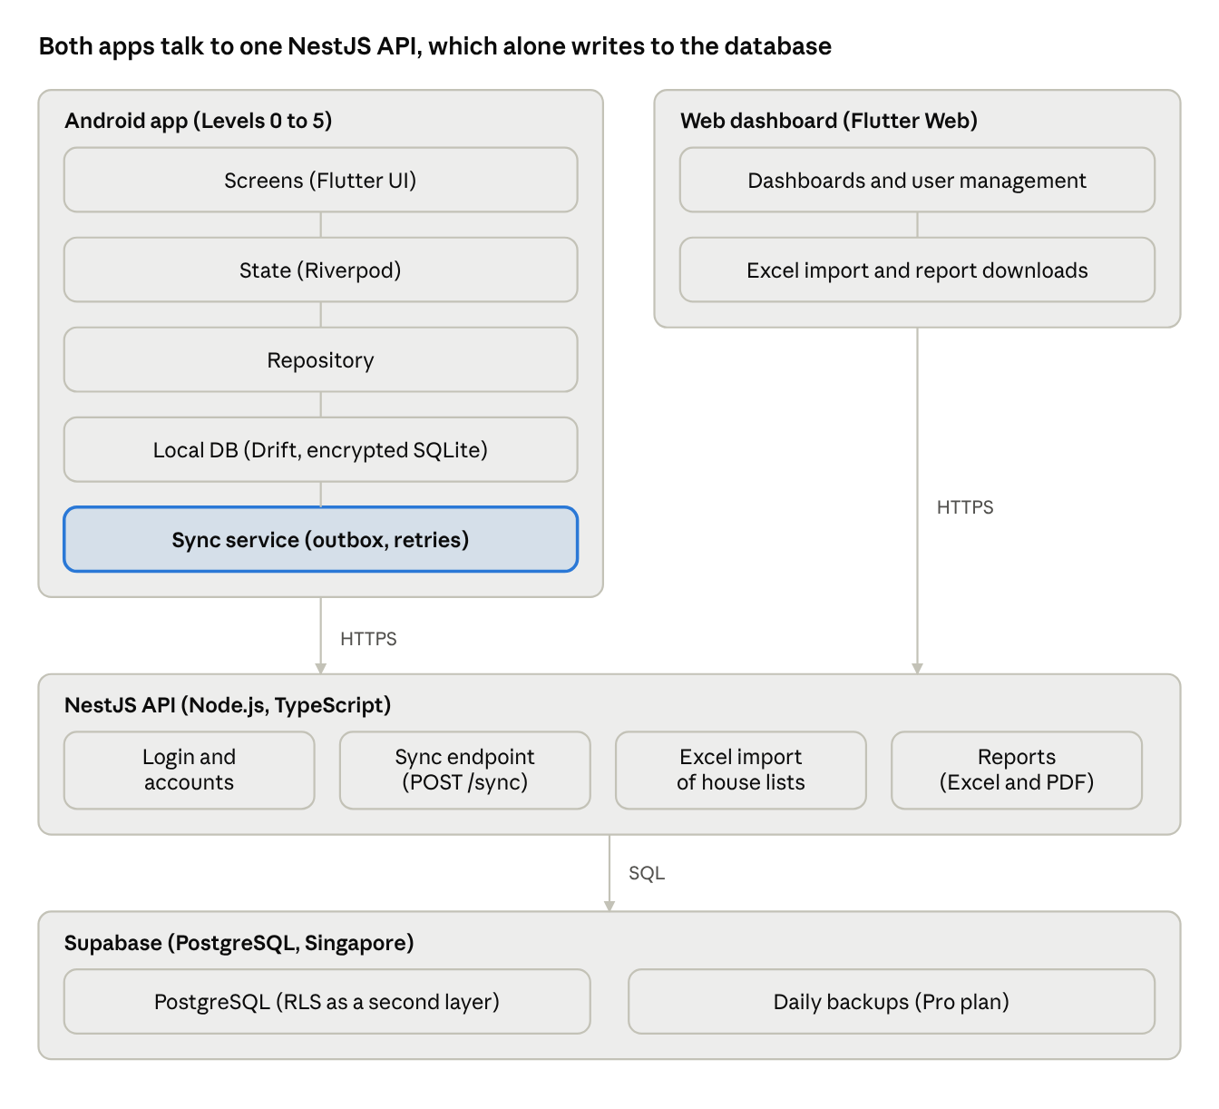
architecture · 2 apps, NestJS API, Supabase
Both apps reach the data only through the NestJS API; the phone does so through its sync service.

6.1 Scaling for 50,000 to 1,000,000 agents
50,000 to 1,000,000 agents is the long-term goal, not the first launch, so the plan is to build the habits below in from day one and grow the database size in steps. The stack itself stays the same.
Keep sync traffic low
- The app syncs only when records are waiting, never on a fixed timer, and every phone adds a random delay so thousands of phones do not call the server in the same second.
- Records travel in batches (for example 50 at a time), and a record saved while online joins the next small batch instead of making its own request.
- When the server is busy it answers "slow down" with a wait time (HTTP 429), and the app backs off with a growing, randomised delay.
Keep the database fast
- Pick a larger Supabase compute size than the default, test it, and resize after the pilot. Connect through the pooler.
- Index the area columns (district, divisional secretariat, GN division, team) and the user and date columns. Every list is filtered by area and paged by position (keyset), never by offset.
- Save each batch with one bulk upsert, not one query per record.
- When the clients table reaches tens of millions of rows, split it into partitions (by district or by month).
- Keep rows narrow, with long text kept out of the busiest tables.
Keep dashboards cheap
- Totals and progress come from summary tables, updated as records arrive or by a scheduled job (Vercel Cron), not by counting millions of rows on every page load.
- Record tables are always area-filtered and paged.
- Exports and reports run as background jobs that write a file to Supabase Storage and give the admin a download link; they never stream a big file through the API.
Keep accounts manageable
- Admins create accounts in bulk (for example "create 25 team members") and download a credential sheet.
- Login lookups use indexes on the ID and the email, with rate limits per ID, email and device.
- Verification and password-reset emails at this volume need a transactional email plan sized for it.
Prove it before the rollout
- Load test with simulated agents (for example thousands syncing during the 10 a.m. to 3 p.m. window) before the pilot ends, and again before each large district is added.
- Roll out district by district, watching database load and error rates.
- Supabase and Vercel costs grow with usage; get a first estimate from the pilot numbers.
From the client: the busiest hours are most probably 10 a.m. to 3 p.m., so load tests simulate that window. How many records an agent enters per day depends on the campaign and is still unknown, so the test targets stay adjustable.

7. Offline-First Design
This is the most important part of the app. The principle: the phone's local database is the source of truth while working; the server is updated afterwards.

7.1 How saving works
- The agent fills in the form and taps Save.
- The record is written to the local SQLite database with sync_status = pending and a client-generated UUID.
- The agent immediately sees it in their list with a "Waiting to sync" badge. No internet needed.

7.2 How syncing works
Sync starts in three ways:
- Automatic: when connectivity returns, when the app opens, and in the background only while records are waiting, after a random delay so thousands of phones do not call the server at the same moment.
- Manual: the "Sync now" button, with a counter such as "12 records waiting".
- After save: if online, the record joins the next small batch a few seconds later instead of making its own request.
The sync service then:
- Collects all records where sync_status = pending or failed.
- Sends them to the NestJS API (POST /sync) in batches (for example 50 at a time); the API checks the user's role and area, then saves them using upsert by UUID.
- On success, marks them synced and stores the server time.
- On failure, keeps them pending, increases retry_count, and retries later with a growing, randomised delay.
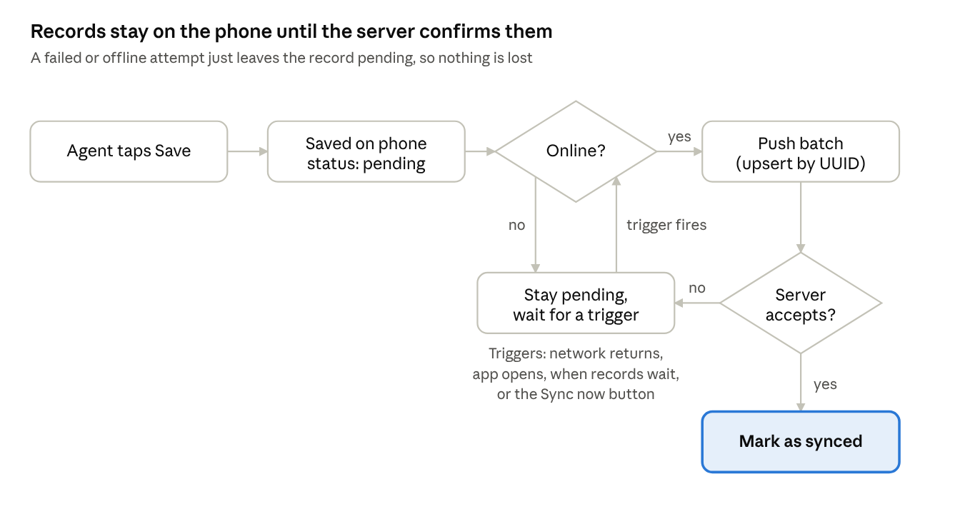
sync flow · 2 decisions, 1 retry loop
Android field data app with offline syncA failed or offline attempt leaves the record pending; the next trigger tries again.

7.3 Why duplicates cannot happen
Because every record has a UUID created on the phone, sending the same record twice simply updates the same row. A dropped connection halfway through a batch is safe.

7.4 Conflict rule (kept simple)
- A house is assigned to one team, so two agents rarely edit the same client.
- If it does happen, last edit wins using the updated_at timestamp.
- Records already synced can still be edited; the edit becomes pending again.

7.5 Data the phone downloads
Before going to the field, the agent taps "Download my area" (needs internet once). The phone stores:
- The team's house list and their pre-filled house details
- Dropdown values (education levels, vocational streams, jobs)
- The user's profile and assigned team
Level 5 can then work for days offline.

7.6 Login offline
The app keeps the login tokens in Android secure storage. The first sign-in and the first-time account setup need internet; after that the agent can open the app offline. If the token has expired and there is no internet, the app shows a clear message and still lets the agent keep recording data, which waits on the phone until the agent signs in again and sync can run.

7.7 Sync status shown to the user
Status | Meaning | Badge
Draft | Not finished | Grey
Pending | Saved on phone, waiting to sync | Orange
Synced | Safely on the server | Green
Failed | Tried and failed; will retry | Red

8. Database Design (Supabase / PostgreSQL)

8.1 Tables
Table | Key columns
profiles | id, user_code (GRS + 10 digits), email, email_verified, password_hash, must_change_password, full_name, phone, preferred_language, role_level (0 to 5; 00 stored as -1 or a flag), created_by, district_id, ds_id, gn_id, team_id, is_active
districts | id, name_si, name_ta, name_en
divisional_secretariats | id, district_id, name
gn_divisions | id, ds_id, gn_number, gn_name, cdc_secretary_id, secretary_contact, secretary_email
teams | id, gn_id, team_no, leader_id, max_members
households | id (UUID), gn_id, team_id, serial_no, house_no, house_leader_name, address, village_name, is_epf, is_etf, is_aswesuma, is_samurdhi, has_special_needs, target_female, target_male, age_group, lang_sinhala, lang_tamil, lang_english, visit_status, created_by, updated_at
clients | id (UUID), household_id, name, age, gender, address, phone, whatsapp, highest_education, highest_vocational, interested_vocational_stream, interested_job, is_epf, is_etf, is_aswesuma, is_samurdhi, has_special_needs, future_hopes (array), info_provided_by, collected_by, collected_at, device_id, client_updated_at, synced_at
lookup_values | id, category (education, vocational, job), code, label_si, label_ta, label_en
import_batches | id, gn_id, file_name, rows_total, rows_ok, rows_failed, imported_by, imported_at
app_releases | version, min_supported_version, apk_url, checksum, released_at
sync_log (optional) | id, user_id, device_id, records_sent, status, created_at

8.2 Relationships
District → Divisional Secretariat → GN Division → Team → House → Client. Every table carries the area ids so security rules stay simple.
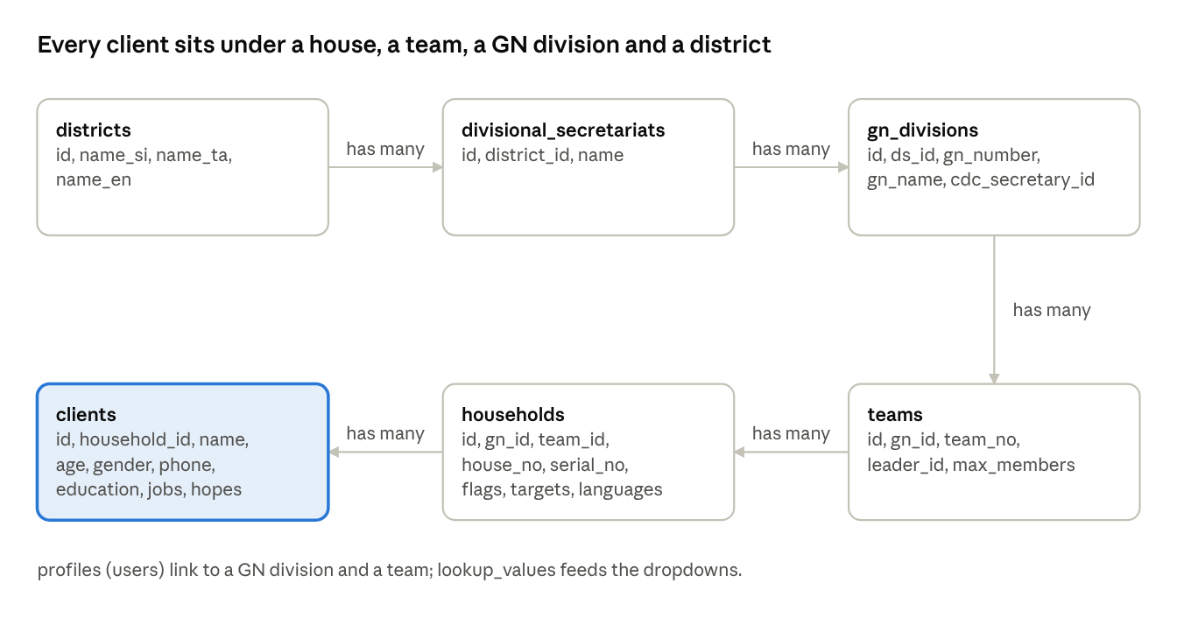
table relationships · 6 tables
Each table nests inside the one before it, so security rules can filter every row by area.

9. Security and Privacy
This app collects personal data of citizens, including phone numbers and welfare status, so security is part of the design, not an extra.
- Authorization in the API: every request passes role guards and an area filter, so Level 5 sees only their own entries, Level 4 their team, and each higher level its own area and below, plus the records they entered themselves. Row Level Security in Supabase stays on as a second layer.
- No direct database access from the apps: only the NestJS API connects to Supabase; the apps never hold database keys.
- Generated IDs and passwords: IDs and passwords are random, passwords are hashed with Argon2 and shown once to the admin who creates them, a new password is forced at first sign-in, login errors never reveal whether an ID exists, and logins are rate-limited with lockout after repeated wrong passwords.
- Encrypted transport and storage: HTTPS everywhere; Supabase encrypts data at rest.
- Agents' own phones: the local SQLite database is encrypted with SQLCipher, the key sits in Android Keystore, and the app can ask for a PIN or fingerprint. The app warns before logout if records are unsynced.
- Lost or shared phones: an admin deactivates the account and the API rejects that phone's tokens immediately.
- Data access: the super admin and admin Levels 0 to 4 can view and export the records of their own area and below; Level 5 sees only their own entries.
- Consent: the app shows a short consent statement before the agent records someone's details, and stores that consent was given.
- Sri Lanka PDPA: confirm who the data controller is and who may access exports; no deletion period has been set yet.
- APK integrity: every release is signed with one protected key and published with a checksum; the app checks its version at startup.
- Backups: daily automatic backups (Supabase paid plan) plus a monthly export kept elsewhere.
- Audit: created_by, updated_at, and device id on every record.

10. App Screens
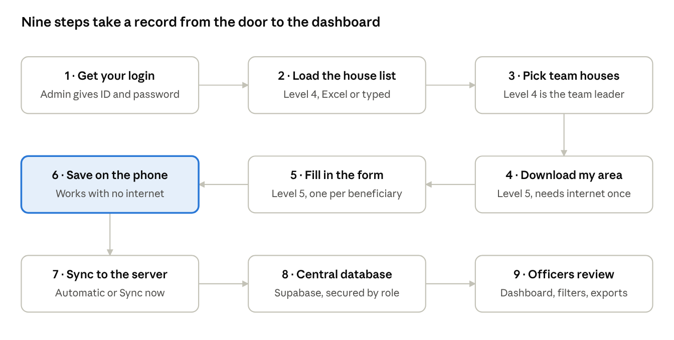
end-to-end flow · 9 steps
Steps 1 to 3 prepare the accounts and the area; steps 4 to 9 repeat as agents visit houses.

10.1 Android app: Level 5 (Team member)
- First sign-in: log in with the ID and password from your admin, choose a new password, and add an email (recommended, because it allows password reset by email)
- Login with ID or email, plus password
- Home: team name, houses assigned, houses done, records waiting to sync, Sync now button, online/offline indicator
- House list: searchable list with status (not visited, partly done, done)
- House detail: pre-filled info (house number, leader, address, beneficiary flags)
- Client form (sections 10.1 to 10.13 of the form), with "Save and add next beneficiary" and "Save and finish house"
- My records: everything I entered, with pending and synced status and an edit option
- Settings: language (Sinhala, Tamil, English), download my area, logout

10.2 Android app: Level 4 (CDC Secretary), in addition
- GN division setup (secretary details)
- Add houses by typing, one at a time (serial number auto-generated); bulk Excel import is on the web dashboard
- Choose the houses for your team from the GN division's list; a house can belong to one team only, and houses taken by another team show as taken
- Create team members: the ID and password are generated and shown once; the admin sets the team's member limit, and a full team cannot take more members
- Team progress overview
- Team records: view the records entered by the team

10.3 Android app: Levels 0 to 3
- Create accounts for the level below and for your own team members, one at a time or in bulk, with a credential sheet to share
- Enter data with the same client form as Level 5
- View the records related to your level: your own entries and your area's records, with filters and search
- Progress overview for your area

10.4 Web dashboard: all levels, Level 00 first
- Login with ID or email
- Dashboard: totals and progress by district, division, GN division and team; each level sees its own area, and the numbers are pre-calculated
- User management: create accounts for the level below (one at a time or in bulk, with a credential sheet to download), deactivate accounts, reset passwords
- Area and team management: districts, divisions, GN divisions, teams, and a member limit for each team (set by Level 00 for now)
- Excel import of house lists, with a preview and an error report per row
- Records: tables of the records related to the signed-in level (own area and below, plus own entries), with filters (area, language, beneficiary type) and export to Excel/CSV
- Reports (Excel and PDF) in Sinhala, English or Tamil
- Data entry for admins, with the same client form as the app
- Sync health: which teams have unsynced data (optional)

11. Project Phases and Timeline
Estimates are for a small team of one to two developers and are rough; adjust after the pilot.
Phase | What gets built | Output | Estimate
0. Finalise requirements | Confirm both forms, dropdown values, role rules, Excel template columns, our own report layouts, data retention | Signed-off field list, roles and report formats | 1 week
1. Backend foundation | NestJS project, Supabase database, tables, login by ID or email, generated IDs and passwords, forced password change, role guards, seed districts and lookups, test accounts per level, a Vercel test deployment (region, import, reports), indexes and summary tables for scale | Working secure API | 2 to 3 weeks
2. Android app: Level 5 core | Login and first-time password change, language switch, download my area, house list, client form, local Drift DB, save offline | Agent can record data with no internet | 3 weeks
3. Sync engine | Outbox, sync endpoint, auto and manual sync, retry, background task, sync status UI | Data safely reaches the database | 2 weeks
4. Level 4 features | Typed house entry, choosing houses for a team, creating team members, team progress overview | Secretary can prepare the whole GN division | 2 weeks
5. Web dashboard | User management with bulk account creation, team member limits, Excel house-list import, data tables, progress (Level 00 first) | Level 00 can manage, monitor and export | 3 weeks
6. Reports | Excel and PDF reports designed for this platform, report language choice | Reports approved by the client | 1 to 2 weeks
7. Languages and polish | Native-speaker review of Sinhala, English and Tamil, fonts, validation, error messages | Field-ready UX | 1 to 2 weeks
8. Pilot | One GN division, 5 to 10 agents on their own phones, direct APK install, a load test with simulated agents, fix issues | Pilot report | 2 weeks
9. Rollout | Training material, signed APK download page, in-app update check, support | Live campaign | 2 weeks
10. iOS (later) | Build and test the same Flutter code on iOS, App Store release | iOS app | 2 to 3 weeks
Total to Android launch (Levels 00, 4 and 5): roughly 21 to 24 weeks, including about 2 weeks for scaling work and load testing. Phases 1 to 4 deliver the core value; the dashboard can start smaller if officers first rely on exports, and the report layouts need client sign-off in Phase 0. Levels 1 to 3, with account creation, data entry and their own records views, follow the first launch and are not in this estimate; Level 0 waits until its role is decided.

12. Testing Plan
- Offline scenarios: airplane mode, saving 100 records, reconnecting; killing the app mid-sync; switching networks mid-sync.
- Duplicate check: sync the same record twice and confirm one row.
- Security: log in as each level and confirm no records outside their area are visible, and that each level's records view shows only what is related to it.
- Accounts: a generated ID and password work for the first sign-in, a new password is forced, an email can be added and then both the ID and the email log in, a full team refuses new members, two team leaders cannot claim the same house, and a deactivated account is refused at once.
- Excel import: missing columns, blank rows, duplicate house numbers, and Sinhala and Tamil text in the file.
- Reports: check each report against the layout the client approved, in all three languages.
- Own phones: several phone brands, including 2 to 3 GB RAM models and Android 10 as the lowest version; install the APK directly and update from an older version.
- Language: Sinhala, Tamil and English on every screen, with correct text rendering and keyboard entry.
- Load: simulate thousands of phones syncing in the same hour and check response times, error rates and database load.
- Field pilot: a real GN division before national rollout.

13. Risks and How We Keep It Simple
Risk | Mitigation
Sync bugs lose data | Never delete local records until the server confirms; keep "synced" copies for 30 days
Agents with low technical skill | Big buttons, clear sync badges, short training, Sinhala/Tamil UI
Poor internet for days | "Download my area" once; queue is unlimited
Scope creep | Freeze the field list in Phase 0; extra features go to a version 2 list
Privacy complaints | Consent screen, role guards, encryption, limited export rights
Android background limits | Always provide the manual Sync now button as backup
API or Supabase outage | Local data remains safe; sync resumes automatically
Generated login details shared or leaked | Random IDs and passwords, forced password change, rate limits, and an admin can reset or deactivate an account
Agents' own phones vary widely | Minimum is Android 10; test on low-end phones running it
Lost or shared phone | PIN lock, encrypted local database, immediate account deactivation
Direct APK is blocked or distrusted | Signed APK, checksum, one download page, install guide with screenshots, Google Play later
Bad data in Excel files | Row-by-row validation and a preview before anything is saved
Report layouts change | Keep report templates in one API module; agree layouts with the client in Phase 0

14. Open Items to Confirm
Confirmed
- The app is called the Global Research & Survey App (GRS); the Door-to-Door Skills Campaign is its first use.
- Role titles DC and SDA are used as written in the DD/S/002/2026 document; Level 1 is Admin CG.
- Dropdown lists for education, vocational streams and jobs are accepted; they live in a lookup table so they can change later.
- The house list is loaded by bulk Excel import and by typed entry; the Excel template columns are checked against the election name list layout.
- Agents use their own phones, Android 10 or newer.
- The dataset is accessed and owned by the super admin and admin Levels 0 to 4, and each level sees the records related to it.
- The app is distributed as a direct APK for now.
- Reports are this platform's own reports, not a government format.
- The Level 4 account acts as the team leader and chooses the houses for their team; each team has its own Level 4 leader only.
- Each team has its own member limit (for example 10 members in one team and 20 in another), set by Level 00 or Level 0; for now Level 00 sets it.
- Admin Levels 0 to 3 can also use the mobile app and enter data, and Levels 1 to 3 can create their own team members' accounts.
- Admins create accounts with a generated ID (GRS plus 10 digits) and a random password; users can change the ID to their email and change the password, and can log in with either.
- The NestJS API keeps no data of its own; records go to Supabase once synced. No deletion period is set for now.
- The NestJS API is hosted on Vercel.
- Expected agents: 50,000 to 1,000,000 is the long-term goal and the first launch is smaller; the busiest hours are most probably 10 a.m. to 3 p.m.
Open questions and checks
- Level 0: its role has to be decided with the client.
- Who creates which accounts: assumed that each level creates the level directly below plus its own team members (section 3.2); confirm with the client.
- Build order: assumed Levels 00, 4 and 5 first, then Levels 1 to 3.
- Scale: how many agents the first launch will have and how fast it grows toward the long-term goal, so database size and costs can be planned in steps. Records per agent per day depends on the campaign and is still unknown.
- Vercel test deployment in Phase 1: confirm the region, Excel import and report generation work within Vercel's limits (see section 6).
- The Excel template columns come from the format file (see section 4.3); check them against a real election name list file once the client provides one.

15. Summary
Build the Global Research & Survey App as a Flutter Android app with a local encrypted database and an outbox-style sync, a NestJS API on Vercel for login, sync, Excel import and reports, Supabase PostgreSQL as the central database, and a Flutter Web dashboard. Admins create accounts with generated IDs and passwords, and users can switch to email login. Plan for a long-term goal of 50,000 to 1,000,000 agents with the measures in section 6.1, and keep everything in Sinhala, English and Tamil. Keep the forms exactly as the paper versions, freeze the scope early, pilot in one division with a direct APK, load test before wide rollout, and extend to iOS afterward from the same code.

